

2020 FLORIDA STRAWBERRY FESTIVAL®
QUEEN’S SCHOLARSHIP PAGEANT

Sponsored by the Plant City Lions Club

January 18, 2020, 6:00 p.m.
FLORIDA STRAWBERRY FESTIVAL®
GRIMES AGRICULTURE CENTER

Chairperson: Gail Lyons 813-967-6366
813-567-7071


RULES AND REGULATIONS

Competition open to: see rules C and F

Applications Available: online, www.flstrawberryfestival.com & www.plantcitylionsclub.com www.Flstrawberryfestivalqueenspageant.org
MANDATORY ORIENTATION: Milton E. Hull Building (Armory)
3:00 P.M. - Sunday, October 20, or 5:30 P.M. - Monday, October 21,
or 5:30 P.M. - Tuesday, October 22, 2019
Applicant must be accompanied by a Parent or Guardian Application Deadline: Tuesday, November 12th, 2019 by 5:00 P.M.

The Florida Strawberry Festival® Queen’s Pageant is sponsored by the Plant City Lions Club, which will conduct the pageant through the selection of the five finalists and coronation ceremony of the 2020 Florida Strawberry Festival® Queen and her court at the Florida Strawberry Festival Grounds on January 18, 2020.

- LIMITED NUMBER OF CONTESTANTS: The contest will be limited to thirty-five who will be accepted on a first-come basis. These will be kept on file if any of the thirty-five applicants drop out prior to November 29th, 2019 On or after Nov. 29th, no contestant will be replaced.

- FILING OF APPLICATIONS: Applications can be obtained on the Florida Strawberry Festival website, www.flstrawberryfestival.com and the Plant City Lion’s Club website, www.plantcitylionsclub.com. Completed application, with one identification wallet-sized photo of the applicant attached, a $25.00 entry fee and document that shows permanent domicile address, and a PRINTED TRANSCRIPT WITH MOST CURRENT DISTRICT GPA SIGNED BY REGISTRAR must be HAND DELIVERED to the Festival office located at 303 BerryFest Place, on or before 5:00 p.m., Tuesday, November 12th, 2019. MAILED

APPLICATIONS WILL NOT BE ACCEPTED!

- AGE, SEX AND SCHOOL STATUS: The applicant must have been born a female whose age must be at least sixteen years of age and cannot be more than twenty years of age as of March 1, 2020. The applicant must be a junior or higher and must be enrolled in and attending high school, a home school program or attending a post secondary education or training. The applicant must have a 3.0 weighted Grade Point Average and (must attach a PRINTED TRANSCRIPT WITH MOST CURRENT DISTRICT G.P.A SIGNED BY REGISTRAR) and whose permanent address is within our current area boundaries.

- PROCESSING OF APPLICATIONS: The Lions Club Sponsoring Committee will pick up the completed applications from the Festival office and will determine the eligibility of the applicants as related to residence, age, schooling, and other general rules of the contest. Each applicant will be informed of her acceptance or rejection as a contestant after November 15th, 2019.

- COMPLIANCE WITH RULES AND REGULATIONS: The applicant’s signature on the application will be considered as evidence that the applicant has read all the rules and regulations of the contest, and that the applicant agrees to abide by all rules and regulations and understands that information provided
will be verified. Applicants must attend all announced meetings and rehearsals. Failure to follow this rule without just cause will be cause for elimination from the contest.

- AREA BOUNDARY FOR CONTEST: MUST SHOW PROOF OF RESIDENCY, WILL ONLY ACCEPT COPY OF

TAMPA ELECTRIC BILL. ONLINE PAYMENTS; AN ELECTRONIC PRINT-OUT OF PAYMENT IS ACCEPTABLE.


NORTH BOUNDARY:

EAST BOUNDARY:

SOUTH BOUNDARY:

WEST BOUNDARY:

Beginning at the intersection of US 301 and the Hillsborough/Pasco County Line, go East along the County Line to the Hillsborough/Polk County Line

From the Northeast Hillsborough County Line go South to intersect the imaginary Easterly Extension of State Road 672 (Balm Picnic Road)

From the intersection of Balm Boyette Road and State Road 672 (Balm Picnic Road) go east and continue the imaginary Easterly Extension of State Road 672 to intersect the Hillsborough/Polk County Line.

From the Hillsborough/Pasco County Line go South on US 301 to the intersection of McIntosh Road. Go South on McIntosh Road to the intersection of Jaudon Road. From that intersection go Southerly on a straight line to the intersection of Balm Boyette Road and State Road 672. See boundaries map on page 6.

Other than the County Line Boundaries eligibility is open to addresses on either side of a Boundary Road.

- GENERAL ELIGIBILITY: Former Florida Strawberry Festival® Queens or Court Members are not eligible to compete.

- PERSONAL STATUS: An applicant must be single, who’s fixed, permanent and principal home for legal purposes is within the area boundary for the contest. The applicant must never have been married or have had a marriage annulled. The applicant must not be pregnant or ever have borne a child.

- MARRIAGE OR PREGNANCY: Because marriage or pregnancy could interfere with their fulfilling their responsibilities to the Festival, if the queen and/or any member of the court marries or becomes pregnant during the year she is responsible to the Florida Strawberry Festival®, she will be removed.

- MORAL CHARACTER: Applicant or contestant must never have been arrested. She must not have been suspended (out of school) during the current or previous school year.

- PRIOR CONDUCT: Applicant must have never performed any act or engaged in any activity or employment that is or could reasonably be characterized by the Florida Strawberry Festival® General Manager as dishonest, immoral or indecent. Social media is considered an activity and will be examined for all contestants.

- RESPONSIBILITY OF THE QUEEN AND MEMBER OF THE COURT: After the final selection of the queen and members of the court, the queen and members of the court will be responsible for participation in all events scheduled by the Florida Strawberry Festival® Board until a new queen and court are selected. The queen and each member of the court shall portray good conduct, good morals, and good manners. They will conduct themselves with dignity and always be a credit to the Florida Strawberry Festival®. Failure to follow this rule will be considered cause for dismissal. If at any time, actions or behavior is inconsistent to the Florida Strawberry Festival®, disciplinary action or removal of title will be at the sole discretion of the Florida Strawberry Festival® Board of Directors.

- ABDICATION OR DISQUALIFICATION: In the event the queen should abdicate her title or become disqualified, the first maid shall become the queen. In the event the first maid or a court member should abdicate or become disqualified, no successor will be named nor, will a new court member be appointed. In case of any abdication or disqualification of the reigning queen or member of the court, said queen or court member may be asked to return all gifts and gratuities that she has received in relation to the event. Any unused scholarship will be forfeited.

- ACTIVITIES RESTRICTED FOR CONTESTANTS: Upon acceptance into the Florida Strawberry Festival Pageant, contestants may not participate in any other pageant or activity which conflicts with the Florida Strawberry Festival® Queen’s Pageant including all rehearsals. Failure to follow these rules will be considered cause for elimination from the contest. In the event these rules are not followed by any contestant, a Lions Club representative, Florida Strawberry Festival® General Manager and Queen Coordinator will determine the course of action. Members of the 2019 Queen & Court will not be permitted to participate in any other pageants, (except for school sanctioned events, i.e. Calendar Girl, Homecoming, etc.) until their commitment to the Florida Strawberry Festival® has been completed.

- USE OF CONTESTANTS: During the selection process, no attempt should be made by anyone to use any of the contestants in any kind of program, presentation, performance, or representation unless approved in


advance by the Lions Club Sponsoring Committee and the Florida Strawberry Festival® General Manager and Queen Coordinator. No person who is not approved in advance by the Lions Club Sponsoring Committee shall have anything to do with the orientation meeting of the contestants or the elimination contests.

- MANAGEMENT CONTRACT OR ENDORSEMENTS: During the pageant process the contestants (and following the pageant, the queen and court) may not:

  - Sign a management contract with any individual, business or corporation.

  - Give verbal or written endorsement of any mercantile commodity or any commercial organization.

  - Permit photographs of herself to be used with any advertised commodity or service.

The Florida Strawberry Festival® General Manager and Plant City Lions Club must be notified of any prior commitments or contracts at the time of her application to determine her eligibility.

- JUDGING PROCEDURE: Announced decisions will be final. Documents pertaining to judging decision will be destroyed.

- CLOTHING/DRESS/APPEARANCE: Each contestant must furnish her own clothing and accessories, including casual wear, a career dress or coordinate, and an evening gown. The Lions Club will provide guidance pertaining to attire. No visible tattoos or body piercings (except ear piercings) will be allowed. Inappropriate clothing as demonstrated by the distributed guidelines will result in a 10-point deduction from your score.

- CONSENT OF PARENTS OR GUARDIANS: An applicant under eighteen years of age must have signed, notarized permission of her parent or legal guardian to participate in the contest. The signature of the parent or legal guardian on the application will be considered as their consent.

- DRESSING ROOM TO BE CLOSED: The dressing room will be closed to everyone except contestants and pageant directors. Rehearsal is closed to everyone except participants and pageant directors.

- GIFTS AND OTHER INCENTIVES: The Florida Strawberry Festival® will provide the following gift incentives included, but not limited to:

  - Wardrobe provided for Festival events
  - A crown for the queen
  - Trophies and sashes for each of the five finalists
  - Other gifts and incentives

- SCHOLARSHIPS TO BE AWARDED: The Plant City Lions Club will provide a $1,200.00 scholarship for the 2020 Florida Strawberry Festival® Queen, a $1000 scholarship for the first maid, $800 scholarships for each of the three court members, and $400 scholarship for Miss Congeniality 2020. The Florida Strawberry Festival® will provide a $1,400.00 scholarship for the 2020 queen, a $1,200.00 scholarship for the first maid, and $1,000.00 scholarships for each of the three court members for 2020. The scholarships will be issued to the college of their choice or post secondary education or training facility upon receipt of official registration. All scholarships must be used within four years of serving on the court.

- Anyone participating in this contest by way of entry, hereby agrees and consents to the use of any picture of contestant in any or all publications, TV, publicity brochure, internet, etc., that the Florida Strawberry Festival® may desire.

Failure to attend any one of the mandatory meetings listed below may result in disqualification from the contest.

Mandatory Meetings:

*ORIENTATION - For the 2020 Queen contestants on Sunday, October 20, 2019 at 3:00 p.m., or Monday, October 21, 2019 at 5:30 p.m. or Tuesday, October 22, 2019 at 5:30 p.m. in the Milton E. Hull building (Armory) on the Florida Strawberry Festival Grounds.

*SOCIAL – Saturday, December 6th, 2019 at 3:00PM Location to be determined.

* REHEARSALS – January 2nd, 2020 Arthur Boring Civic Center 6:00PM
January 7th, 2020 Arthur Boring Civic Center 6:00PM
January 9th, 2020 Arthur Boring Civic Center 6:00PM
January 14th, 2020 Arthur Boring Civic Center 6:00 PM

*PAGEANT REHEARSAL – Thursday, January 16th, 2020 at 5:30 p.m., Friday, January 17, 2020 at 5:30 p.m., in the Florida Strawberry Festival Grimes Agriculture Arena. Contestants will need to be on grounds by 5:00 p.m. to purchase their tickets.

*PERSONAL INTERVIEW - Saturday, January 18, 2020 at 10:00 a.m. on the Florida Strawberry Festival Grounds, exact location to be announced. All contestants are required to meet with the judges. Contestants will be notified of exact time of her interview and arrival time.

*PAGEANT AND CORONATION NIGHT - 6 p.m., Saturday, January 18, 2020 in the Florida Strawberry Festival Grimes Agriculture Arena. Contestants must arrive at 5:00 p.m.

*OTHER EVENTS AS SET BY THE LIONS CLUB PAGEANT COMMITTEE.

FITTINGS AND PREPARATIONS: A Florida Strawberry Festival® representative will be in contact with the new queen and court on the fittings and preparations.

THE COMPETITION

The contestants will be judged on the four divisions of Personal Interview Competition, Public Speaking Competition, Casual Wear and Evening Gown Competition. Of the total points awarded for the above divisions, the following percentages will be awarded:

Personal Interview Competition | 25%
Public Speaking Competition | 15%
Casual Wear | 30%
Evening Gown Competition | 30%

No less than four judges will be used for the Pageant. Judges will be chosen from a list of accredited judges.

PHASE ONE: The personal Interview will take place on Saturday, January 18, 2020, (time and place to be announced later). All contestants are required to meet with the judges. The attire for this interview is career dress or coordinates. The same outfit must be worn for the Public Speaking Competition of the pageant. In this division, the contestants will be judged on the personal interview only, with no relation to their other qualifications. The criteria for this division are as follows:

The young lady selected as the Florida Strawberry Festival® Queen will represent the Florida Strawberry Festival® and the City of Plant City, both locally and elsewhere. Her overall appearance and her personality will be observed for desirable traits. She should be able to speak effectively and should be well versed on information concerning the Florida Strawberry Festival®, Strawberry Industry and the City of Plant City. In responding to questions and in discussion of the industry she expects to represent, she should portray sincerity, enthusiasm, friendliness, and congeniality. She should appear to be at ease with adults and should demonstrate a desirable degree of maturity. Because making appearances and speaking or promoting the Florida Strawberry Festival® for a full year will be her responsibility, she should not plan to enter other contests or assume other responsibilities that would conflict with her obligation to the Florida Strawberry Festival®. Finally, she should be of good moral character and should be the kind of young lady whom the Florida Strawberry Festival® and the people of the community would be proud to have represent them.

THE PAGEANT

Florida Strawberry Festival Grounds, Saturday, January 18, 2020, 6:00 p.m.

PHASE TWO: A continuation of the competition begins with this phase. The contestants will now be judged on the Public Speaking Competition only, with no relation to their other qualifications. The attire is to be the same career dress or coordinates as worn in the personal interviews.

A. In an opening introduction of the contestant and her sponsor, the contestant presents a speech of not more than 30 seconds pertaining to her sponsor. She will be judged, in part, on the effectiveness of her speaking voice, proper grammar and diction over the microphone. (A 1-point deduction will be taken off the score for every second over the allotted time limit). Stage Presence: Each contestant will be judged on her walk, carriage, general presentation, posture and stage personality.
C. Overall look on stage: Each contestant will be judged on her beauty, poise and choice of attire.
D. No Props can be used.

PHASE THREE: The contestants will be judged on Casual Wear only, with no relation to their other qualifications. The criteria for this division are as follows:

Casual wear is defined as denim jeans and a top.

In this division, the contestants will be judged on beauty, poise, posture, carriage, stage presence and stage personality.

PHASE FOUR: The contestants will be judged on the Evening Gown Competition only, with no relation to their other qualifications. The criteria for this division are as follows:

A. Stage presence: Each contestant will be judged on her walk, carriage, general presentation, posture and stage personality.

B. Overall look on the stage: Each contestant will be judged on her beauty and poise.

The judges will score the contestants separately for each phase of the competition. Neither the judges, chairman, nor auditor should disclose any information concerning the scores. In case of a tie vote in the tabulation of semifinalists, the auditor will inform only the chairman of the judges’ committee of the tie vote. Only the judges will be involved in breaking a tie vote. Neither the judges, the chairman, nor the auditor should disclose any information concerning the tie vote, or the way it was resolved, except as indicated above.

After the ballots have been tabulated and points awarded in each division, the auditor will prepare a list of the names of the ten semifinalists for the first elimination in random order. Contestants are not to be listed in the order of points received.

FINAL ELIMINATION

The 10 semifinalists will now be competing against each other and will be judged on the following criteria:

Impromptu Public Speaking | 25%
Overall Look | 40%
Stage Presence | 35%

Impromptu Public Speaking: The semifinalists will be asked the same impromptu question on her opinion of the Florida Strawberry Festival®, strawberries or Plant City. She will be judged on her ability to speak effectively in public, her speaking voice and her diction over a microphone.

Overall look on the stage: Each contestant will be judged on her beauty, poise and appearance in her gown.

Stage presence: Each contestant will be judged on her walk, carriage, general presentation, posture and stage personality.

this division to the judges. The judges will score the contestants and record these scores on their ballots. From the judge’s tally sheet, the auditor will determine the five finalists who received the highest number of points. In case of a tie, the scores from the preliminary competition will be used to break the tie. From these finalists, a queen, 1st, 2nd, 3rd and 4th runners-up will be selected according to the highest number of points scored. The placement of the 2nd, 3rd and 4th runners-up will not be announced.

THE CORONATION

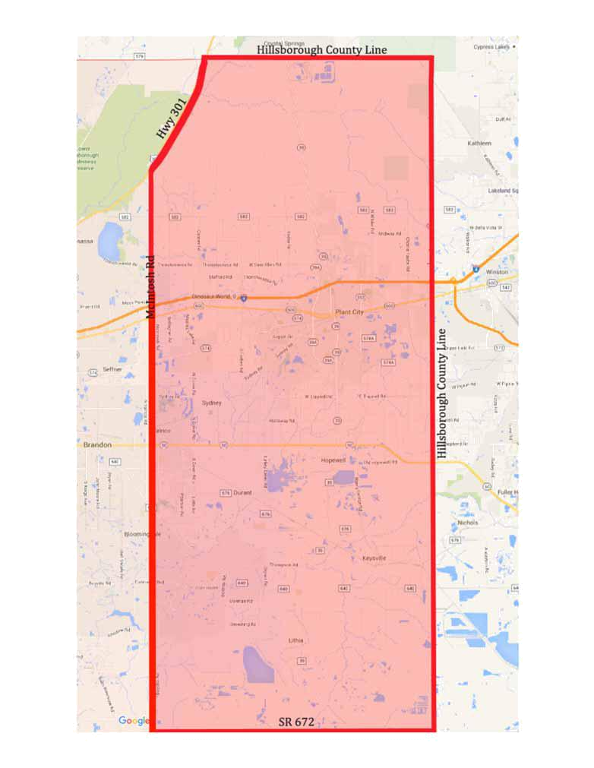
The coronation will begin with the abdication of the current queen and court and presentation of the new queen and court. Immediately after the coronation of the new queen, the auditor will destroy all tally sheets.

